**Modified Thermoelectric Generator and its applications in EVs and smart wearables**



**BIRLA INSTITUTE OF TECHNOLOGY AND SCIENCE,PILANI**

**FINAL REPORT**

**SUBMITTED IN FULFILMENT OF DESIGN ORIENTED PROJECT COURSE INSTR F376**

**FIRST SEMESTER 2020-21**

**BY**

**Jash Shah 2018A8PS0507P**

SUBMITTED TO

**Dr. Sujan Yenuganti**

Assistant Professor, Department of Electrical & Electronics Engineering

BITS Pilani, Pilani Campus

SUBMITTED ON

**28 November 2020**

## **Abstract**

Thermoelectric generator has humongous potential in the market in future. Traditional approaches of enhancing a thermoelectric generator have been focusing on chemical and material properties, and on the mechanical structure of the heat exchanger. This has been on account of the fact that voltage generated depends only on the temperature difference across the module. In this research, it has been hypothesized that power generated by the module may be of higher value for application and this , along with the temperature difference, also depends on the heat transfer occurring between the junction. Keeping this thought in mind, the project aims at researching upon various innovative implementations of the Thermoelectric generators. Further, it has been proposed to implement the Thermoelectric effect using a different technique, rather than the traditional methods of implementation. We will not be using the standard P-N strip approach but instead, use mixtures of MS Junctions and implement it using transistorial approach, thus, developing a better and efficient Thermoelectric Generator.

The research project also extends its application to the field of Electric Vehicles and smart wearables. The heat generated from the accumulator and/or body, collectively with the heat sink provided by the coolant, can be effectively used to generate current while capping the heat source temperature below the safe limits. Further, we will design an efficient heat transfer method, for the application and research for the best material amalgamation for getting the most efficient output of the thus, re-designed Seebeck generator.

## **Table of Content**

1. Abstract
2. Introduction
3. Thermoelectricity
   1. Thermal Model
   2. Electric Model
   3. TEG based sensor
4. Literature Review
   1. Material Analysis
   2. Series and Parallel combinations
   3. Efficiency Analysis
5. Using the TEG for Automobile Industry - ATEGs
6. Using TEGs for Smart Wearables
7. Innovations in TEG based systems
8. My idea
   1. TEG modification
   2. Using in Electric Vehicles
9. Future Works
   1. Heat Sink Improvements
   2. Experimentations
   3. Porting to EVs
   4. Researching for Smart Materials

**References**

**Appendix**

**Appendix A** : Analysis of Commercially available TEG module.

## **Introduction**

Much attention has been given to waste power recovery in recent years. With the fast industrial growth of developing nations over the last decade, the industrial sector consumed approximately 2852 MTEP. It is estimated that in 2035, the world consumption of energy will increase by more than 30%. About 33% of this power is lost as heat [1]. The use of TEGs to recover waste heat energy has increased rapidly in recent years with applications in

fields such as remote sensing , automotive , stove, geothermal, space systems and industrial power plants.

The global energy crisis has paved the way for re- searchers to explore alternative means of generating power. In order to minimize the waste of energy with residual heat, energy recovery systems have been more explored. These systems can become an important object of research and/or application if, at least, part of the thermal energy expelled by industrial equipment to the atmosphere can be reused One approach to providing electrical energy is by direct conversion of heat to electrical power with the use of thermoelectric generators (TEGs). It is attractive to use TEGs because they have no mechanical parts; hence resulting in an alternative power system that is silent, stable, reliable, environment-friendly, and possesses virtually unlimited lifetime [2].

In 1821, Thomas J. Seebeck discovered that an electromotive force or potential difference could be produced by a circuit made from two dissimilar wires when one junction was heated. This is called the Seebeck effect. In 1834, Jean Peltier discovered the reverse process that the passage of an electric current through a thermocouple produces heating or cooling dependent on its direction. This is called the Peltier effect (or Peltier cooling). In 1854, William Thomson discovered that if a temperature difference exists between any two points of a current-carrying conductor, heat is either absorbed or liberated depending on the direction of current and material. This is called the Thomson effect (or Thomson heat). These three effects are called the thermoelectric effects [20]. The Seebeck effect is basically, a direct energy conversion of heat into a voltage potential. The recent boom in this technology has been owing to the growing knowledge of semiconductors based devices that have promised better performance. Having said this, the TEG technology is still not perfect and has many disadvantages : Higher output resistance [3], Lower efficiency, High production cost, Low thermal Conductivity and Higher Cost of Additional mechanisms

A lot of work has already been done for increasing the efficiency of the module by exploring material science and changing the heat transfer assembly. Available literature also includes experimentation with combinations of series and parallel TEG modules and other off the track topics like Mechanical properties of such materials, as described *Gilad and Yaniv* in[6]. Nearly all the research has been shifted to semiconductor based materials and other advanced materials. Recent innovation by MIT mentions a material capable of holding heat, which can be further used to generate electricity, where and when required. Korean scientists have been involved in working on novel materials to realize body warmth as the source of heat. Not only solid-state devices, but several ionic liquids have also been experimented for potential use in TEG technology. Multi-stage Peltier devices are being developed to improve the coefficient of performance (COP). In recent days, multistage thermoelectric cooling devices have been developed as many as six stages with bismuth telluride-based alloys [21].

Industrial automotive giants like BMW and Tesla have been spending a lot of money for this research. The AETEG project launched in 2009, involving GM motors included a commercial ATEG that was capable of generating around 140 to 225 W of recycled power !

My work is unique as it typically exploits 3 unexplored ( or less explored ) domains i.e. Electrical manipulations in terms of system level aspects, Constant Temperature heat transfer characteristics and multi-staged TEG sensors. Further, my work also targets 2 applications where this technology can be expanded at a very huge scale : Electric Vehicles and Smart Wearables. The research assumes that these 2 sectors hold the highest potential of consuming TEGs, in terms of usability and thus our research is also particularly centered around typical circuitry and methodology used in these fields. The analysis thus differs from traditional ATEGs that were used for Combustion vehicles, which has been broadly described in ([4], [5]).

Heat source and sinks are readily available in the form of accumulator/body heat.

The paper also investigates better and efficient heat transfer mechanisms, without incurring additional cost and power. This research will thus pioneer new technologies in the TEG industry.

## **Thermoelectricity**

The term Thermoelectricity is made up of 2 terms thermo and electricity, which simply means that such materials are capable of both generating electricity and consuming electricity using thermal or heat related tradeoffs, which are explained by Seebeck and Peltier effects respectively. This effect is observant owing to the random movement of charge carriers, resulting in 2 inevitable processes that are heat transfer and charge transfer. This very property of materials is used in many domains including waste heat regeneration, Temperature measurement devices - RTDs and electric coolers.

Usually, thermoelectric generators (TEG) are solid-state semiconductor devices that convert a temperature difference and heat flow into a useful DC power source. Thermoelectric generator semiconductor devices utilize the Seebeck effect to generate voltage. This generated voltage drives electrical current and produces useful power at a load.

It usually occurs due to the movement of charge carriers within the semiconductors. In doped n-type semiconductors, charge carriers are electrons and in doped p-type semiconductors, charge carriers are holes. Charge carriers diffuse away from the hot side of the semiconductor. This diffusion leads to a buildup of charge carriers at one end. This build-up of charge creates a voltage potential that is directly proportional to the temperature difference across the semiconductor. The figure presented below illustrates the same:

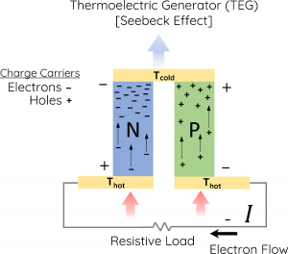

*Fig : Seebeck Effect effect demonstration*

Seemingly, this is a very simply concept, having an approximate Voltage - Temperature relation wherein the voltage generated across the module ( i.e. one N-strip and one P-strip ) is given by the very famous equation :

V = S ; where S is the seebeck coefficient.

The thermodynamic model is developed using the concept of difference in Fermi Levels of the same strip at different temperatures. This leads to development of charge carriers, producing a diffusion current from the hot side to cold side. Correspondingly, an reverse Electric field is generated which blocks the further movement of charge carriers also called the drift current. This equilibrium is broken down when additional and oppositely charged carriers are supplied, developing a closed loop of current carrying path.

The subsequent sections elaborate more over the previously explained general idea. We thus separately discuss the thermal and electrical aspects of developing a thermoelectric generator and finally extend the discussion to TEG as a sensor.

### **Thermal Model**

Heat flux, the most important parameter in thermoelectrics was defined by Onsager’s principle and was given as :

where the quantity “heat flux” is given as (k is the thermal conductivity of any material) and is defined as the flow of energy per unit of area per unit of time. In SI its units are watts per square metre (W/m2).

Further analysis gave rise to the general heat transfer equation, which is given by :

Which at steady state, reduces to :

### **Electric Model**

The simplified model equation shown above has been derived from the basic Ohm’s and Fourier’s laws. Simplifying them, we get the following equation:

The heat flux at steady state is given as the dot product of Electric field generated and current density of the generated current. This gives us the following equation, which forms the basis for the general equation of thermoelectricity :

And hence, at steady state, the equations reduce further. The current formed is very difficult to measure in case the circuit is incomplete. Hence, we apply an additional resistive load and thus, the overall voltage generated is given as :

It is very important to note that this equation is an ideal equation that is widely used in mostly all applications. It assumes ideal steady state conditions in case of heat transfer and other equivalents.

### **TEG based Sensor**

Despite having lots of disadvantages, the TEG is still under enormous research due to the following major benefits it has to offer([6], [9]) :

1. **Zero dependencies -** The TEG sensor has an unconditional potential to convert heat to electricity at even very low-temperature differences and that too without any limitations. They provide direct conversion( without using turbines or other secondary conversion elements) of energy making them extremely fast.
2. **Reliability** - Thermoelectric generators are solid-state devices. Having no moving parts to break or wear out makes them very reliable. They literally have zero maintenance costs. Their design is mechanically less complex.
3. **Long-life** - TEGs have a very long-lasting life, one of the primary reasons being they don't undergo any kind of wear and tear or rust.
4. **Quiet** - Thermoelectric generators can be designed to be completely silent.
5. **Highly Scalable and flexible -**  TEGs can be scaled and/or designed to fit into any space, given the right combination of 2 materials and electrical expertise. Their compact design may also increase the flexibility of the sensor.
6. **No Greenhouse Gases** - Thermoelectric generators do not require any greenhouse gases to operate. Some energy conversion technologies do.
7. **Mountable in Any Orientation** - Thermoelectric generators operate in any orientation. Some energy conversion technologies are sensitive to their orientation relative to gravity.
8. **Operation Under high and Zero G-forces** - Thermoelectric generators can operate under zero-G or high-G conditions. Some other energy conversion technologies cannot.
9. **Renewable source of Energy** - Thermoelectric generators are made of semiconductor materials and they work on the principle of movement of charge carriers. Hence, they provide a very good source of renewable energy.
10. **Can be made very thin and lightweight**.

## **Literature Review**

### **Material Analysis**

Thermoelectric power generators consist of three major components: thermoelectric materials, thermoelectric modules and thermoelectric systems that interface with the heat source. Usually, the biggest challenge in searching for material is faced due to the tradeoff between electric conductivity and Thermal coefficient. For effective heat transfer, the material must have high thermal coefficient but that would reduce the temperature gradient and thus, leading to low electrical conductivity.

One more consideration to be taken care of, is the thermal expansion coefficient and corresponding compatibility. Thus, a mathematical model by [10] is given as :

Many known materials vary mostly from semiconductor domain, including alloys of Bismuth with Tellurium, Selenium and Antimony. Silicon Germanium alloys and materials fabricated from Lead like Lead Telluride are also widely used.

Recently, rare earth metal alloys have shown exceptional performance. For example YbAl3 has double power efficiency and compatible temperature working ranges. Among the most exciting developments in thermoelectric materials was the development of single crystal tin selenide which produced a record zT of 2.6 in one direction. Other new materials of interest include Skutterudites, Tetrahedrites, and rattling ions crystals [11] .

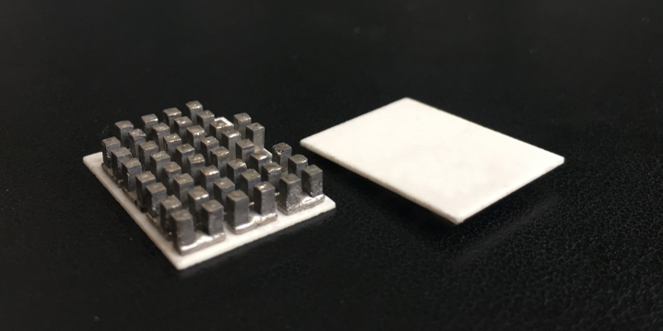

Mostly, alloys of bismuth and Tellurium are being used in developing TEG sensors. All the material used must be in its BTR ( best temperature range) for perfect usage. Some of these BTRs have been listed below :

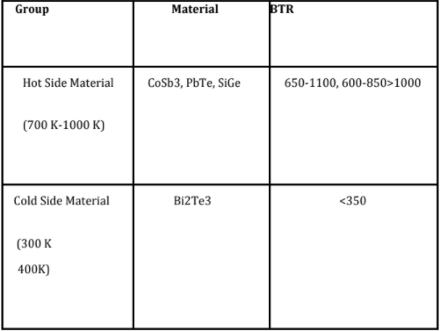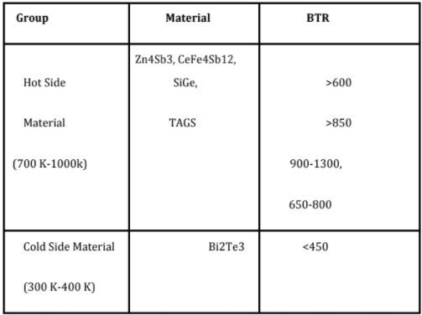

### 

### 

### 

### 

### 

### 

### 

BTR ranges for p-type, N-type and alloys used as ………….TEGs, respectively

### 

### 

### 

### 

### 

Nowadays, special segmented TEGs have been under immense use as they exploit the properties of multiple materials and thus give enhanced efficiency. 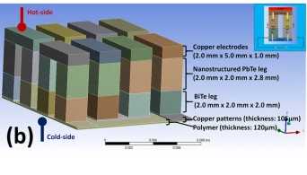

### **Efficiency Analysis**

Defining the efficiency of TEG is a complicated task as it involves modeling of Heat transfer model, along with Electric power generation. As it is, in recent time, very sophisticated mathematical models are now available, but the general efficiency equation can be generalized in the following way:

**ζ**OV = **ζ**CONV х **ζ**HX х r

where, the overall efficiency of the TEG can be defined as a product of Conversion efficiency of thermoelectric materials, Efficiency of the heat exchangers and The ratio between the heat passed through thermoelectric materials to that passed from the hot side to the cold side.

Moving to the complex model, the Carnot efficiency of the TEG is given as term of a dimensionless figure of merit ZT, defined as

Where, S, T, are Seebeck coefficient, absolute Temperature, Thermal Conductivity and Electrical Resistivity, respectively.

{ * Please note that in some literature, the symbol for Seebeck coefficient is .}

But, according to many scholars, this model does not account for temperature dependencies of the Seebeck coefficient *S*, the electrical resistivity *ρ*, and the thermal conductivity *κ.*  Hence, a better and more accurate model as explained in [7] is :

Image ID:c7ee02007d-t2.gif

Here, is the maximum Seebeck efficiency which is clearly defined as the ratio of Output Power with respect to Input Heat.

While considering a simple electric model, we can define the efficiency in terms of electric parameters. A detailed discussion has already been offered in section 4.a. For derivation purposes, I would like to use a single load resistance in series with the TEG module. A simplified diagram has been given below:



*Fig : Simple equivalent circuit for*

*TEG based simulations.*

Correspondingly, the Output voltage would be given as V = S ΔT, where S is the Seebeck coefficient. As the power across Load is given as , we ge a simplified equation as :

PL =

Also the output efficiency of the Seebeck generator will thus, become, which equivalently turns out as :

## **ATEGs - Using TEG for Automobile Industry**

One of the biggest challenges in using TEGs for the Automobile Industry comes due to the Temperature - Voltage tradeoff, as discussed above. While considering the power production aspect, we must not forget that our sole purpose is to remove heat from the accumulator/engine and exhaust pipe. Otherwise, it will become a huge threat to the passengers.

Obviously, the basic expression of the figure of merit clearly signifies that for efficient power generation and efficient cooling, both Seebeck coefficient and High electric conductivity is required. This is also accompanied by lower thermal conductivity. This is a big problem while selecting materials for an ATEG. The following figure displays the different material property and their characteristics with respect to Seebeck coefficient, Thermal conductivity and electrical conductance :

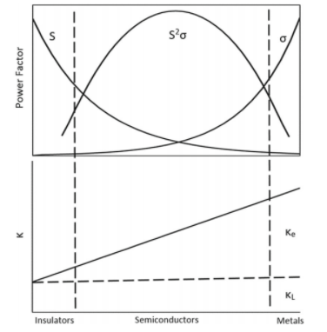

In ATEGs, thermoelectric materials are packed between the hot-side and the cold-side Accumulator module. In some cases, this is also attached to the heat exhaust pipe. When hot exhaust from the engine passes through an exhaust ATEG, the charge carriers of the semiconductors within the generator diffuse from the hot-side heat exchanger to the cold-side exchanger.

The compression assembly system aims to decrease the thermal contact resistance between the thermoelectric module and the heat exchanger surfaces. In coolant-based ATEGs, the cold side heat exchanger uses engine coolant as the cooling fluid, while in exhaust-based ATEGs, the cold-side heat exchanger uses ambient air as the cooling fluid.

With exhaust temperatures of 700 °C (≈1300 °F) or more, the temperature difference between exhaust gas on the hot side and coolant on the cold side is several hundred degrees. This temperature difference is capable of generating 500-750 W of electricity.

## **Using TEGs for smart Wearables**

. The main difference between developing a TEG for Smart wearables comes from the fact that over here, we do not have to maintain the body temperature above a certain range. On the other hand, maintaining body comfort comes into the picture here.

Generally, Al2O3 plated modules, sandwiched between copper and ceramic plates are used as flexible TEGs which can be used over fingertips as well.

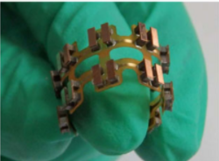

Experimental results also show the variation in voltage difference while walking and sitting. This could be of great use not only for generating electricity but also keep a track of irregularities in body temperature, which in turn can be used for greater benefits to humanity. The graphs obtained in the experiment done by Yaoguang Shi, Yancheng Wang in [23] are as follows :

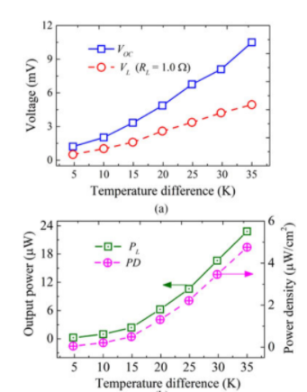

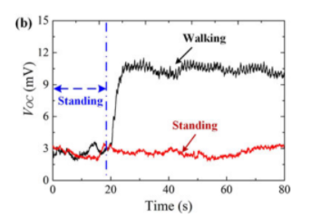

## **Innovations and modifications in traditional TEG based systems**

Several different modifications have been made to traditional TEG based systems. Although most of them correspond to using a better and efficient material, configurational and modal changes have also been made in several papers. The detailed study and experimentation are yet to be done for these innovations. A general overview of each of these is given below :

1. **Using Parallel and Series Combinations**
2. **Using Cylindrical TEG systems**
3. **Using Heat Concentrators**
4. **Using a DC-DC converter for Vehicles**
5. **Modelling the TEG-WHR system for efficient output based on the system requirements**
6. **Using Organic Transistors**
7. **Using High-Efficiency Skutterudite Modules at a Low-Temperature Gradient**
8. **Developing Robust Mechanical Structures**
9. **Analysing Efficiency loss due to non-uniform temperature gradients.**
10. **Using Complex materials and Platinum sheets for increasing efficiency**
11. **Multi-stage TEG modules**

2 types of topologies exist for multi-stage TEG design: Homogeneous(same material in all the layers ) and Hybrid (different materials are used).

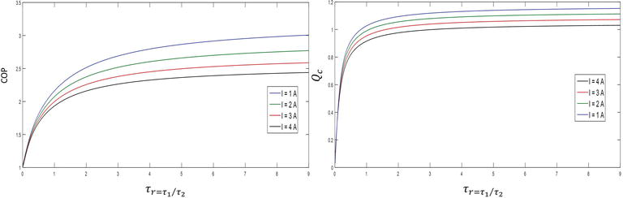

## **My Idea**

As mentioned in the introduction, the main crux of my idea is to play with different electrical modifications in the TEG design, instead of using the traditional TEG modules. Using Smart and advanced materials would be considered in the second phase of the project and have thus been included in the Future Works section. As discussed earlier, the next 2 sub-sections will aim for dealing with the 4 main problems associated with TEG modules.

### **TEG design Modifications**

1. A simple transistor based model is to be designed for the TEG module. P-N strip based models have many limitations and this might be solved if we redesign the module’s making itself. A MOS- based design with many different configurations is possible and needs to be experimented with. This simply means using a multi-layered TEG.
2. Using the TEG in reverse breakdown mode or Avalanche breakdown mode with increased efficiency using M-S junctions with negative resistance characteristics. Choosing suitable materials, with very less breakdown voltage would help. To achieve reverse bias mode, we can arrange the strips in simple BJT configurations, combined with series and parallel combinations of the same unit.
3. A very prominent problem in VLSI circuits occurs when the circuitry tends to find an infinite looped path of current discharge. This very property can be very useful in such situations, and we can specifically design TEGs to have infinite discharge paths.

### **Specific design for Smart Wearables**

1. Exploiting the fact that the final output of a thermoelectric generator depends only on the final temperature difference, we can also heat up the TEG device at a later stage.
2. Using High-Density materials to store the heat generated by the body.
3. Using cylindrical modules and accessing the current from an axis perpendicular to the heat transfer axis.



### 

### 

Top View Front View

### **Specific design for using in Electric Vehicles**

1. Using a doubly wound strip with different thermal and electric coefficients would also possibly increase the efficiency, where one layer would take care of the electrical characteristics and other would lead to efficient heat transfer. This transversely built capacitor could also help in storing additional charges.
2. One of the major advantages of using materials with higher Temperature coefficients would be the fact that constant heat is being generated in the battery pack and we would need to devise the model on basis of heat input, rather than the temperature of the junction.
3. Using the discharge current of the Precharge - Discharge circuitry to facilitate the performance of the TEG module. The figure below illustrates the same:

## 

## 

## 

## 

## 

## 

## 

1. Using Heat spreader and collector to optimize the locations of maximum heat transfer. Also, utilize the Thermal analysis to detect the hotspots of the battery heat. This would also reduce the cost of fabrication.

## **Future Works**

### **Heat Sink Improvements**

Improving the heat sink and also building some mechanism to reduce heat loss will greatly affect the performance of TEG. This can be achieved by exploiting the structural and thermodynamic measures. The very famous expression PV = nRT can be effectively used for Adiabatic expansion of air, thus giving a much lower temperature at the cold junction node.

### **Experimentations**

A lot of experimentations need to be done. Apart from experimenting with the new ideas, I have presented, many other heat-transfer based theories have to be explored.

The basic idea of experimenting is to present the results and compare them with the already available solutions in the market.

The experiments have been planned in 5 phases

1. Producing results on available commercial TEG modules.
2. Experimenting the same TEGs in different orientations and modes.
3. Studying the effects of constant temperature heat transfer on the modules
4. Experimenting with the new design ideas and with smart materials.
5. Calibrating the module to work in an Electric Vehicle based environment and improving the heat sink characteristics.

### **Porting to EVs**

Using this idea in EV is a much more complex task as the heat generated by EVs is much less when compared to conventional vehicles. Having said that, overheating of the cell container poses a greater risk in the case of EVs. Thus, we need to develop a dynamic system. Using the transistorial model of TEG, we can very efficiently turn the modules ON and OFF.

Using software based solutions, using the BMS will help in effective control of the modules.

### **Researching for Smart Materials**

Lot of new research also revolves around using Quantum Dot, Spin effects and TFT based TEGs. These projects are heavily funded by various government agencies and private firms mostly automobile giants like General Motors, Tesla and BMW.

Sandwich semiconductors, although never used, but seem to have a bright future in this domain.

The basic focus would be to explore the material characteristics, which would be able to release a high order of charge carriers.

## **Conclusion**

The main intention of this work is to provide a wholesome review of TEGs and providing solutions for their applications, specifically for Electric Vehicles. The report starts with a discussion of different available theoretical and mathematical models available for TEGs. This included study of Thermodynamic as well as Electric models. Later sections were mainly on how Thermal energy can be used efficiently as a source of renewable energy and the associated limitations. In the later sections, the goal mainly shifted towards Seebeck Generators Thus, many innovative ideas were presented with the goal of dealing with the limitations which can be broadly classified as 4 main issues : Higher cost of production, Lower efficiency, Low thermal Characteristics and Requirement of Higher Load resistance [8].

Many new advancements in the field of material science and heat transfer were also explored along with their applications. The report also mentions other design geniuses of TEG based systems which include heat concentrators and Quantum Seebeck effects.

The project ends with providing a software based and well experimented solution for integrating the solution in Commercial Electric Vehicles, which can thus be used as a stepping stone for further development.

## 

## **References**

[1]<https://www.intechopen.com/books/advanced-thermoelectric-materials-for-energy-harvesting-applications/heat-recovery-and-power-generation-using-thermoelectric-generator>.

[2] De Leon, MT, Taatizadeh, P, and Kraft, Michael. "Improving the Efficiency of Thermoelectric Generators by Using Solar Heat Concentrators." *MME 2010 Conference* (2010): MME 2010 Conference; 2010. Web.

[3]<https://en.wikipedia.org/wiki/Thermoelectric_generator#:~:text=A%20thermoelectric%20generator%20(TEG)%2C,a%20form%20of%20thermoelectric%20effect>

[4] Wissam Bou Nader, Thermoelectric generator optimization for hybrid electric vehicles, Applied Thermal Engineering,

Volume 167, 2020, 114761, ISSN 1359-4311,

https://doi.org/10.1016/j.applthermaleng.2019.114761.

(http://www.sciencedirect.com/science/article/pii/S1359431119356017)

[5] <http://www.thermoelectricity.eu/documents/poster2017_OSIPKOV.pdf>

[6]<https://www.intechopen.com/books/bringing-thermoelectricity-into-reality/mechanical-properties-of-thermoelectric-materials-for-practical-applications>

[7] Huisheng Peng, Xuemei Sun, Wei Weng, Xin Fang,

5 - Energy Harvesting Based on Polymer,

Editor(s): Huisheng Peng, Xuemei Sun, Wei Weng, Xin Fang,

Polymer Materials for Energy and Electronic Applications, Academic Press, 2017.

[8]<https://www.electrical4u.com/thermoelectric-power-generators-or-seebeck-power-generation/>

[9] <https://thermoelectricsolutions.com/how-thermoelectric-generators-work/>

[10] Snyder, G. (Oct 2003). ["Thermoelectric Efficiency and Compatibility"](https://trs.jpl.nasa.gov/bitstream/2014/7550/1/03-1478.pdf) (PDF). *Physical Review Letters*. **91** (14)

[11]<https://en.wikipedia.org/wiki/Thermoelectric_generator#:~:text=A%20thermoelectric%20generator%20(TEG)%2C,a%20form%20of%20thermoelectric%20effect>

[12] A Novel Design of Thermoelectric Generator for Automotive Waste

Heat Recovery

Kuo Huang1 · Yuying Yan1,2 · Bo Li1 · Yong Li3 · Kai Li4 · Jun Li4

[13] Snyder, G & Toberer, Eric. (2008). Complex Thermoelectric Materials. Nature materials. 7. 105-14. 10.1038/nmat2090.

[14] Ahmed, Aziz & Han, Seungwoo. (2020). Optimizing the Structural, Electrical and Thermoelectric Properties of Antimony Telluride Thin Films Deposited on Aluminum Nitride-coated Stainless Steel Foil. Scientific Reports. 10. 10.1038/s41598-020-63954-0. [ 15 ] Chu, Jing & Huang, Jian & Liu, Ruiheng & Liao, Jincheng & Xia, Xugui & Zhang, Qihao & Wang, Chao & Gu, Ming & Bai, Shengqiang & Shi, Xun & Chen, Lidong. (2020). Electrode interface optimization advances conversion efficiency and stability of thermoelectric devices. Nature Communications. 11. 10.1038/s41467-020-16508-x.

# [ 16 ] Kogo, Gilbert & Xiao, Bo & Danquah, Samuel & Lee, Harold & Niyogushima, Julien & Yarbrough, Kelsea & Candadai, Aaditya & Marconnet, Amy & Pradhan, Sangram & Bahoura, Messaoud. (2020). A thin film efficient pn-junction thermoelectric device fabricated by self-align shadow mask. Scientific Reports. 10. 10.1038/s41598-020-57991-y.

# [ 17 ] A REVIEW OF AUTOMOTIVE THERMOELECTRIC GENERATOR GOVIND MISHRA1, SHUSHIL KUMAR SHARMA 2 1B.E.scholar, D.MAT, Raipur, Chhattisgarh, India 2 Assistant professor, D.MAT, Raipur, Chhattisgarh, India

[18]<https://www.intechopen.com/books/green-energy-advances/thermoelectric-energy-harvesting-basic-principles-and-applications>

# [19]<https://www.intechopen.com/books/bringing-thermoelectricity-into-reality/prospects-and-problems-of-increasing-the-automotive-thermoelectric-generators-efficiency>

[20] <http://homepages.wmich.edu/~leehs/ME539/Chapter%202.pdf>

[21]<https://www.intechopen.com/books/bringing-thermoelectricity-into-reality/thermoelectric-cooling-the-thomson-effect-in-hybrid-two-stage-thermoelectric-cooler-systems-with-dif>

[22]<https://www.intechopen.com/books/thermoelectrics-for-power-generation-a-look-at-trends-in-the-technology/calculation-methods-for-thermoelectric-generator-performance>

[23] Shi, Yaoguang & Wang, Yancheng & Mei, Deqing & Feng, Bo & Chen, Zichen. (2017). Design and Fabrication of Wearable Thermoelectric Generator Device for Heat Harvesting. IEEE Robotics and Automation Letters. 3. 373-378. 10.1109/LRA.2017.2734241.

# **Appendix**

## Appendix A : Analysis of Commercially available TEG module - TEG1-12611-6.0

The bismuth telluride (Bi2Te3) based TEG module is developed by Thermoelectric General Technologies is 1600 square meter technology.

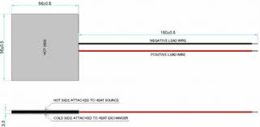

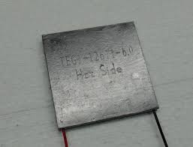

Further details have been provided in the image below :

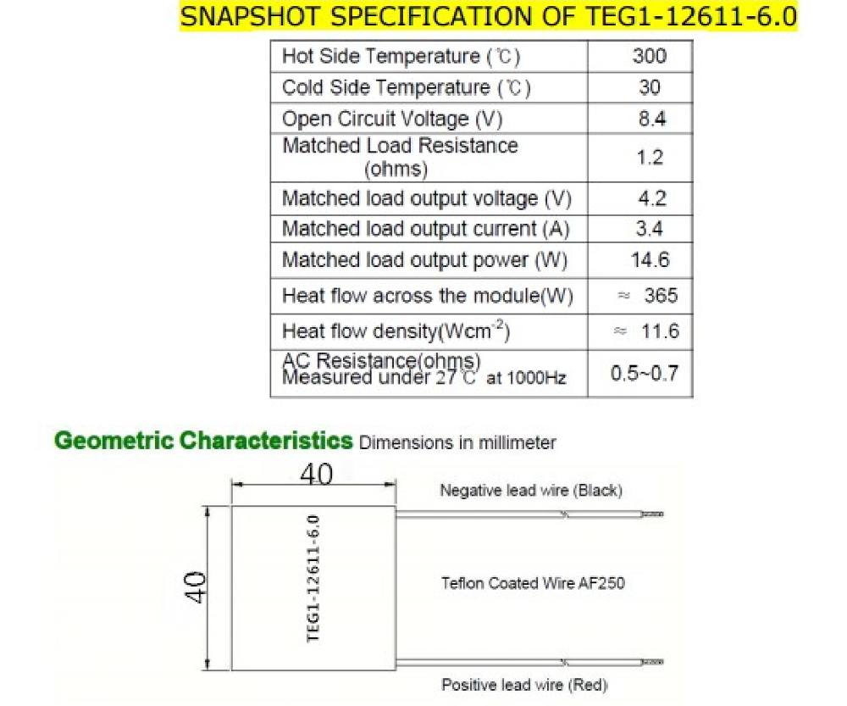

The datasheet also provides detailed analysis of various matrices like voltage, current and power. The following images show the same in graphical format.

